Educational Outreach Proposal
Low Cost Satellite Communications Labaratory
Draft 11 Oct 2006

Proposal. Bob Bruninga
US Naval Academy Satellite Lab
This proposal is to produce a series of low cost hands-on student laboratories to teach the fundamentals of satellite system design and space communications concepts at the high school and college level. The following lab elements are covered using low cost satellite models that can be assembled from off-the-shelf amateur radio components, yet are capable of communications over orbital distances.
• Satellite Tracking: . . . . . Tracking the Moon through the NAVSPASUR radar Fence
• Transmission Lines: . . . . Transmission lines and matching systems.
• Antenna Modeling Lab: Computer Antenna Modeling
• Antenna Lab:. . . . . . . . . .Link budget, Patterns, Gain, Beamwidth, and SWR
• Communications:. . . . . . .Intro to TDMA and FDMA systems and AX.25 protocol
• Receivers/Xmtrs:. . . . . . . RX sensitivity, selectivity, Bandwidth and TX parameters
• Signals / Modulations:. . FSK, AFSK and PSK Modulations and Systems
• Telemetry:. . . . . . . . . . . . Signal conditioning, decoding, 5 channel A/D conversions
• Command/Control: . . . . Command and control of satellite functions
- GPS & Serial Data: . . . . GPS interfacing via serial port downlink.
• Sensors-Imaging: . . . . . . Using an image camera input for image data
• CPU Experiments: . . . . Serial data interface for auxilliary processors or experiments
• Thermal Control: . . . . . Absorbtivity, Emissivity, Conduction.
• Electrical Power : . . . . . .Solar Cells, Primary and secondary batteries and Regulators
• Attitude Control: . . . . . . Passive/active Magnetorquing & Momentum wheels.
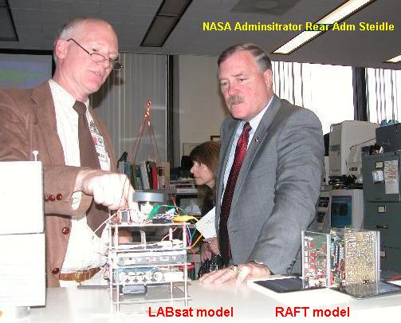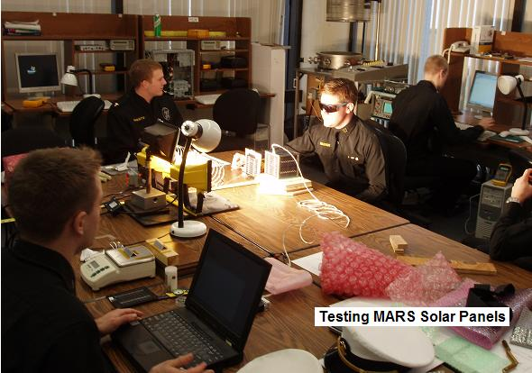
Similar LABsats are being incorporated into the US Naval Academy's Aerospace labs to provide various hands-on experiments with satellite technology at low cost. The photo above shows then acting NASA Administrator Admiral Steidl being briefed on the LABsat system we use to support many of our Aerospace labs.
LABSAT SYSTEM: The LABsat concept is derived from several actual satellites designed and built at the Naval Academy from 1998 to present. The LABsats use the same inexpensive off-the shelf components for under about $600 each ($900 with discrete TX & RX), yet include RF hardware suitable for actually closing the link from orbit in the Amateur Satellite Service. The labsats can not only serve as the final integration of all the modules of the seniors lab course, but they can also serve as rapid prototyping devices for testing modules and components for auxilliary payloads and applications. The Telemetry, Command and Control system communicates at 1200 or 9600 baud using the standard AX.25 packet radio protocol that has flown on MIR, the Shuttle and ISS plus a dozen or more satellites in the Amateur Satellite Service (including 5 of our own). Draft Tech Manual
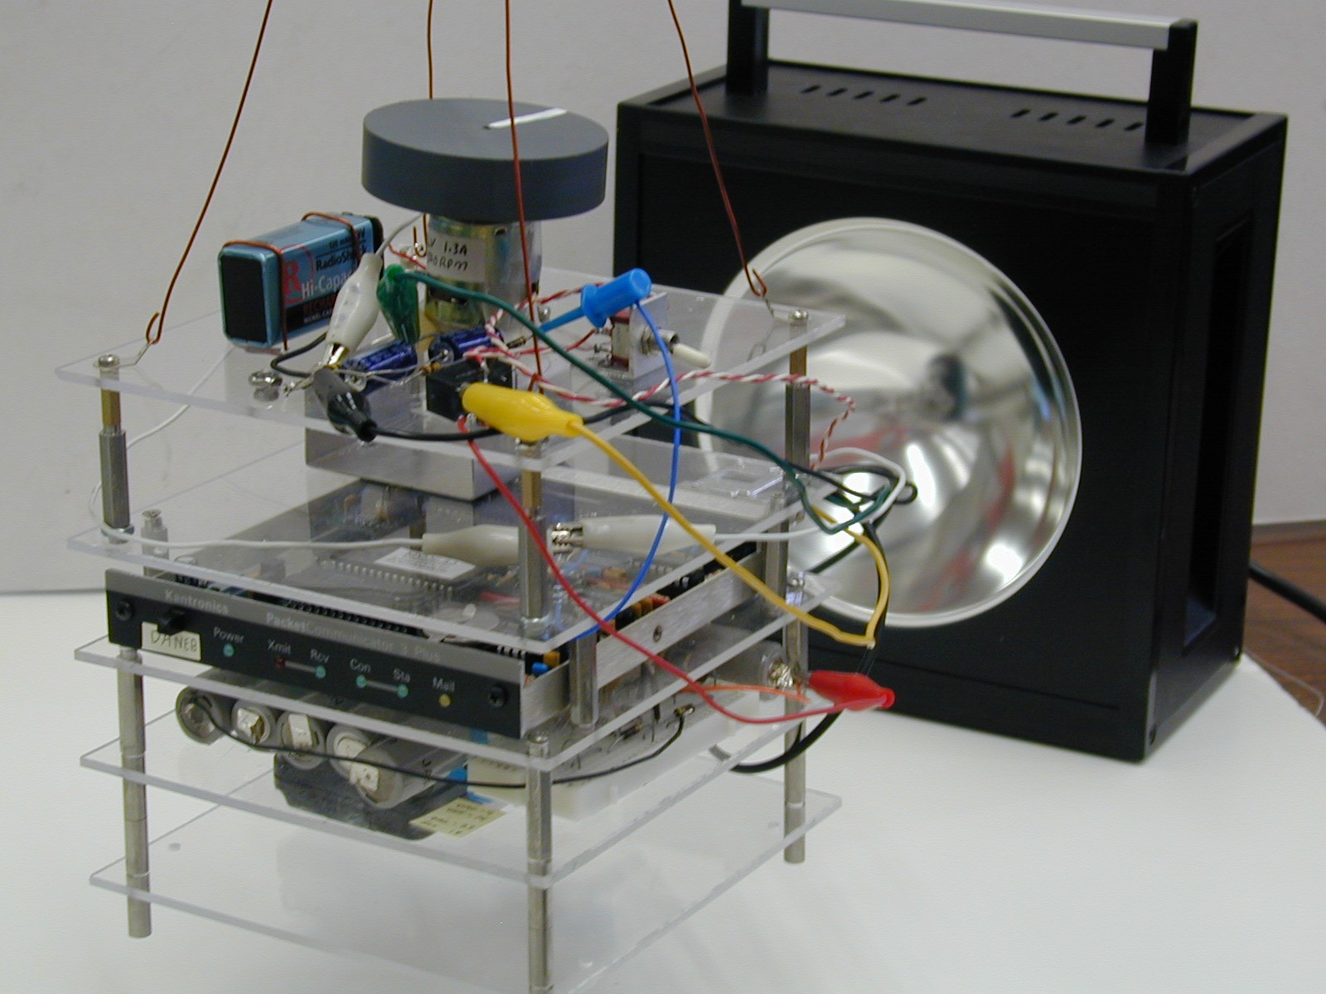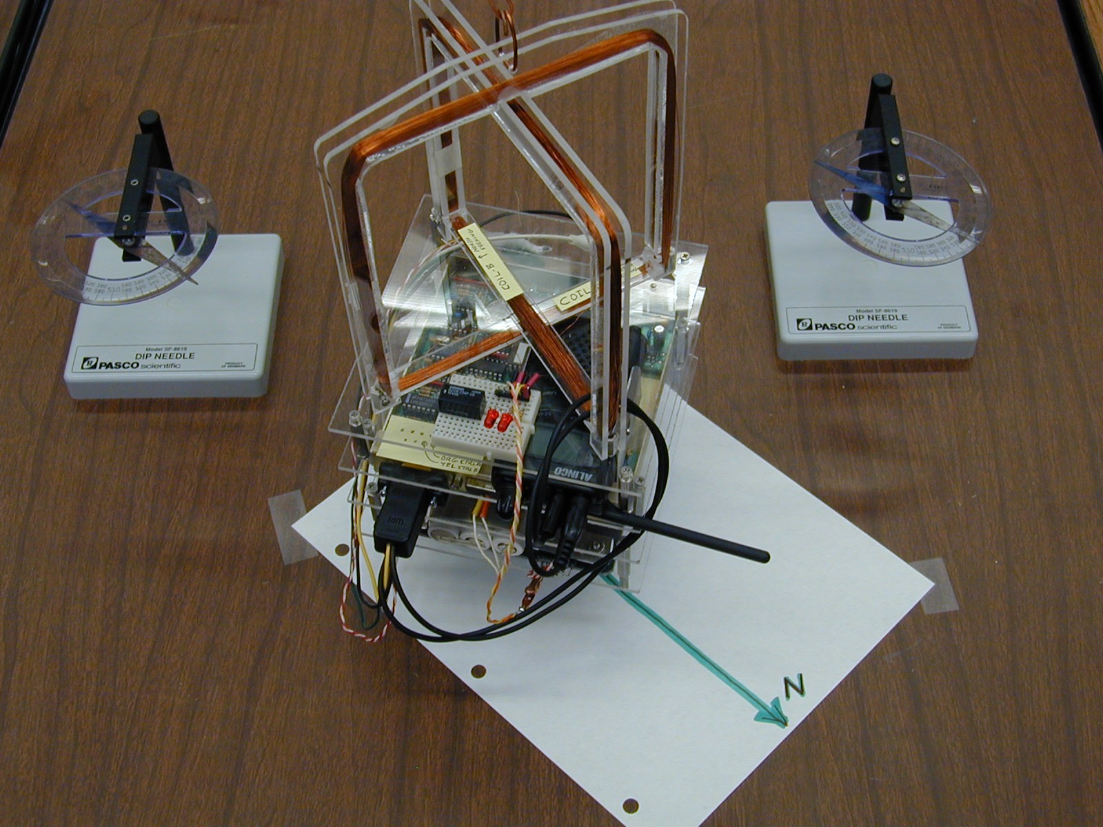
STACKsats: The images above show two typical LABsat stack configurations. These show the momentum wheel and magnetorquing experiments for demonstrating attitude control. The Motor and the orthogonal X and Y torquing coils demonstrate actual attitude control using the Earths magnetic field. When hung from a string, students are able to change the attitude of the labsat, and, with the right pulsing of the coils, spin up or de-spin the spacecraft.
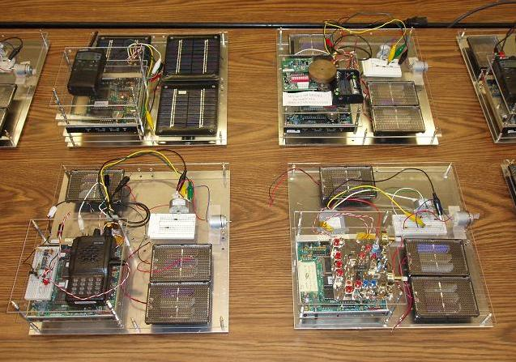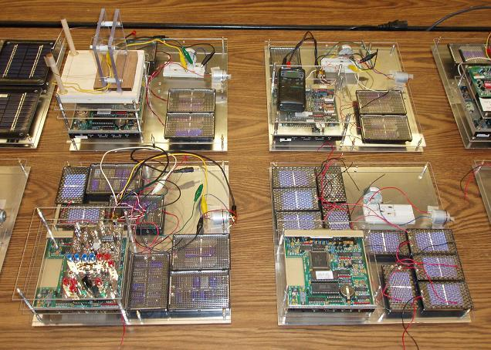
FLATsats: As shown in the 8 different models above, the LABsats can also be configured into a FLATsat configuration for the Electrical Power System (EPS) Solar Panel System design Lab. In the FLATsat configuration, three Solar Panel sides of the spacecraft can be illuminated at once as is the typical illumination of a cube shaped satellite. During the solar design Lab, we have boxes of 8 different solar cell sub-panels of various voltages and currents. The students must design a power system that can be illuminated under a lamp which will power their LABsat including momentum wheel, while staying within the panel size allocated. Cost is also a parameter of the overall design.
ELECTRICAL POWER SYSTEMS: The LABsat is composed of several boards. The image below shows three of the LABsat boards (the RF Transceiver board, a Solar Panel, and the Comand/Control/Telemetry board). The les expensive single radio transceiver board can be replaced with separate TX and RX boards so students can perform individual functional tests on these modules. Other standard boards are the Battery board, and experimental prototype board. The photo on the right shows how the Telemety and Transceiver boards are used to make measurements during the Solar Power lab.
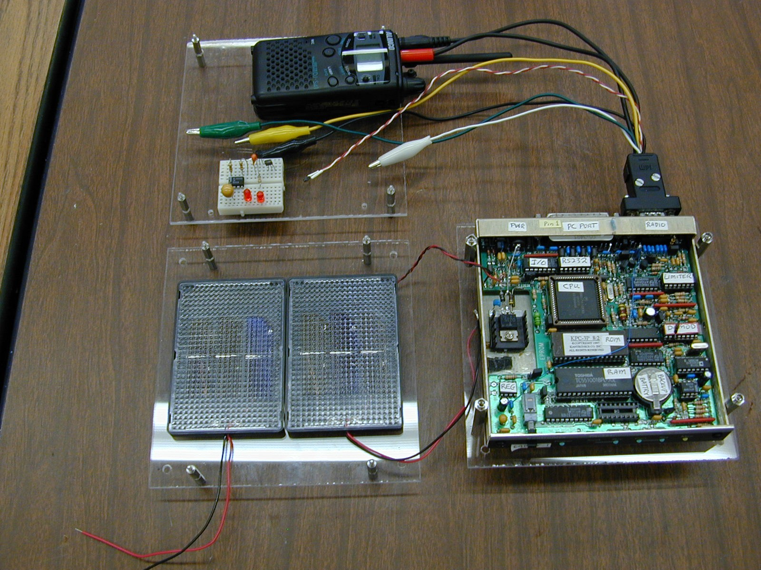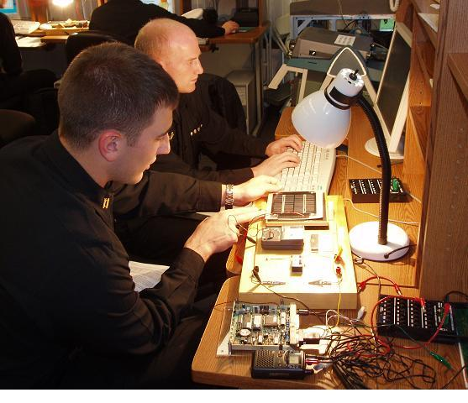
The drawing below shows how the LABsat telemetry system is typically used as a data collection device during experiments. In this case the 4 of the channels are being used to collect Solar Panel voltage and temperature, plus current and battery voltage and discharge current of the torque motor.
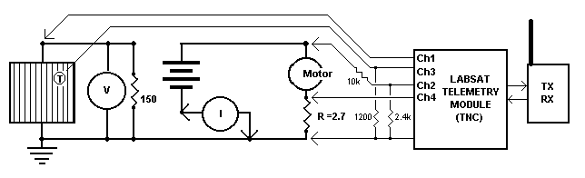
TRANSMITTERS: If the more expensive discrete TX and RX panels (at $200 each) are used, then students can measure and peak the transmitter for peak power out and measure the antenna SWR. They also observe and measure any harmonics or other spurious emissions that are important in passing EMI testing (if a spectrum analyzer is available). This experiment also has the students plot the temperature rise of the transmitter final PA amplifier so they learn the heat generated in a 2W transmitter and how it is mostly concentrated in the final stage and requires thermal design to get rid of it.
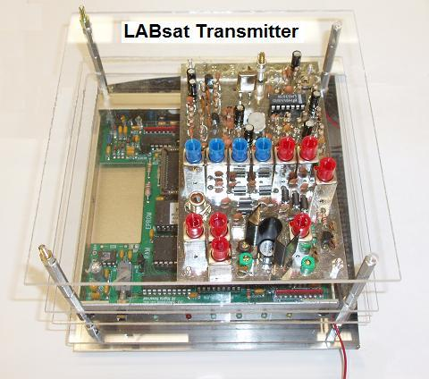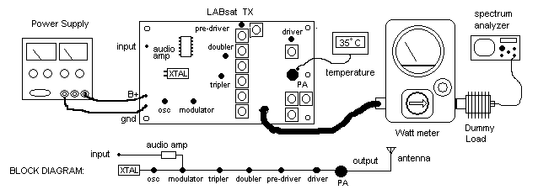
RECEIVERS: On the new discrete receiver, students measure the 10 dB SNR sensitivity and bandwidth as shown below. They measure the noise power on the audio voltmeter and then increase the signal until they achieve 10dB, and then 20 dB SNR. They then move the signal up and down in frequency to measure the 6 dB receiver bandwidth.
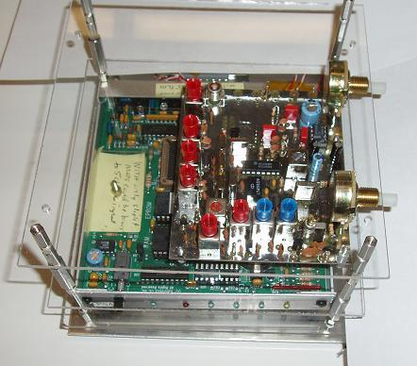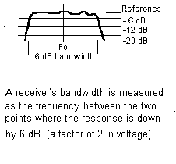
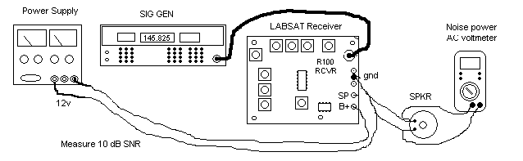
LABsat INTEGRATION: The close up photo of the magnetorquing experiment below shows how the standard 6"x6" modules stack up to compose a LABsat. By having a common footprint, the students have greater freedom in the physical layout of their designs. In the attitude control lab, they have to arrange for a good center of gravity and calculate their moment of inertia. This view, from top down is composed of:
• Payload board: . . . . The top board is the torque coil control board
• Transceiver: . . . . . . The XCVR board can be replaced with separate TX & RX boards
• TNC board: . . . . . . The TNC board has the Command, Control, Telemetry board
• Power System: . . . . The bottom board contains the Electrical Power System
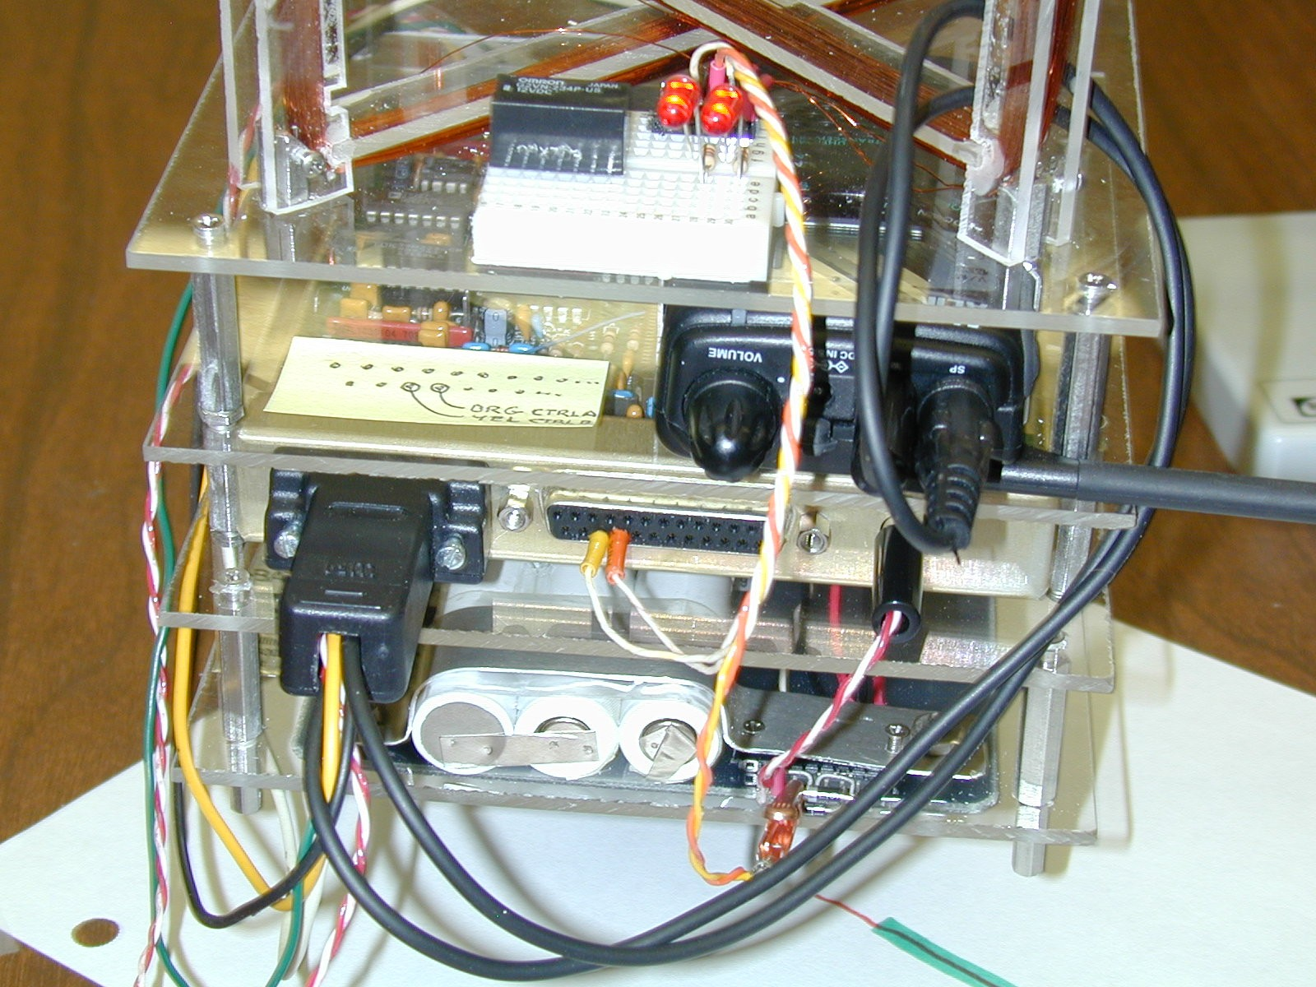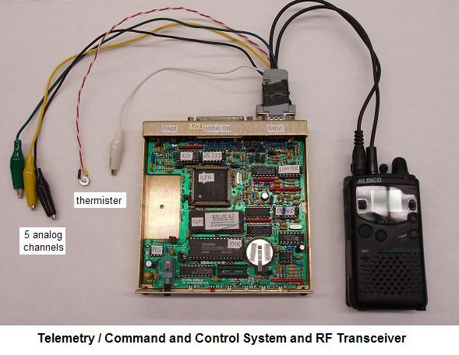
TELEMETRY: The block diagram of the Telemetry Command and control interface is shown below. The bidirectional serial bus allows unlimited expansion to other processors and experiments. This TC&C module is used as the foundation of most of the labsat experiments. It is identical to the eight systems currently flown or manefest on USNA satellites.
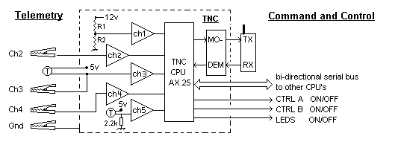
To prepare the COTS packet modem for use as a Telemetry, Command and Control system, we make modifications to the circuitry and make various taps off of many of the microprocessor I/O lines. With these mods, the students can easily access the CPU telemetry inputs and command outputs. The details of the TNC mods are provided in Appendix A.
SIGNALS AND MODULATION:
The students use the Transmitters and Receivers and Telemetry system to investigate both FDMA and TDMA systems. They observe and capture time domain waveforms and compare signals on sound-card spectrum analyzers as shown below. The FDMA multi- channel spectrum display is on the left and the TDMA waveform is on the right.
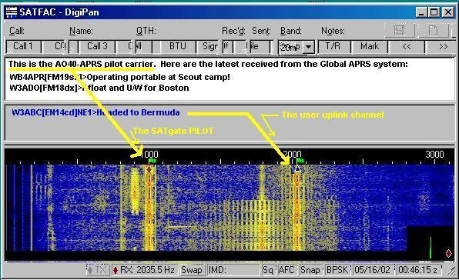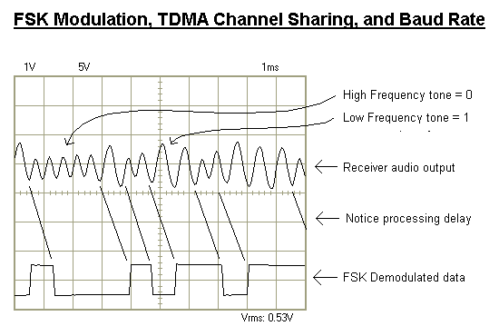
LABSAT GROUND STATIONS: The ground station for both our LABsats and our USNA Satellites on orbit consists of a briefcase system containing a laptop, and AX.25 packet radio modem and small radio. The one shown below uses the Kenwood TH-D7 packet radio that has built-in TNC-modem for easy construction and is suitable for actual comms with the spacecraft on orbit and in the lab. On the right is a GSE laptop connected to our flight RAFT and MARScom satellites. It sh ould be noted, however, that the communications system in each LABsat can also be used as-is, as a ground station too. This way, each student group can act as either a satellite or as a ground station with the same hardware.
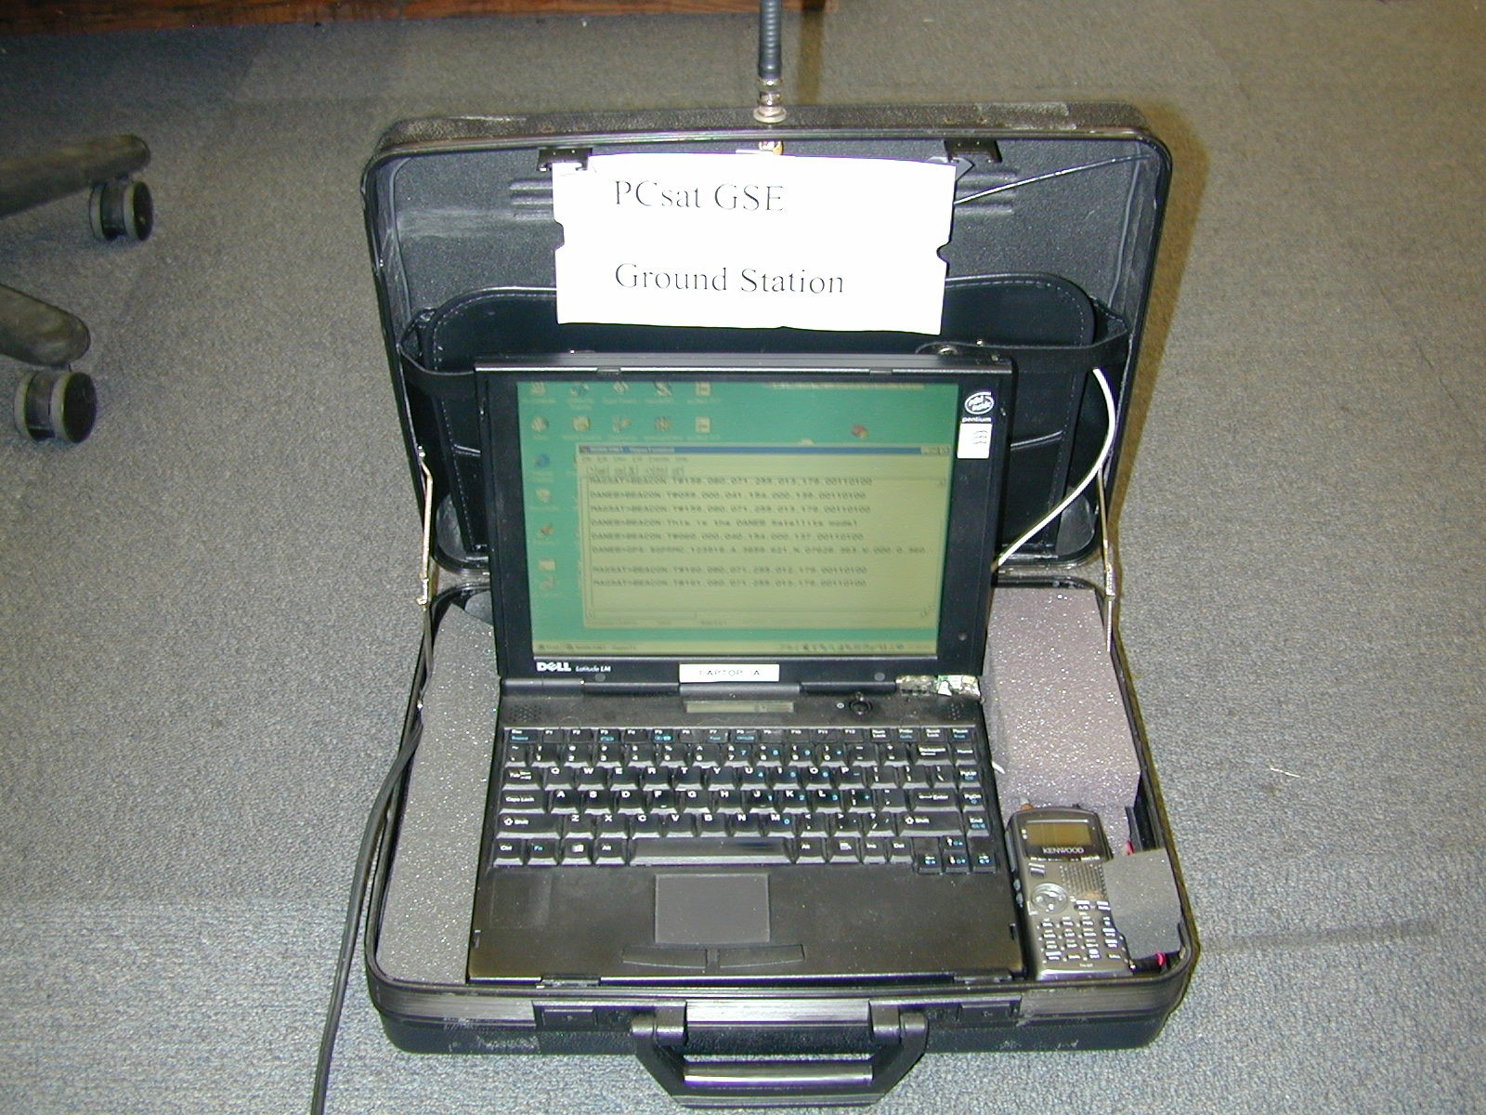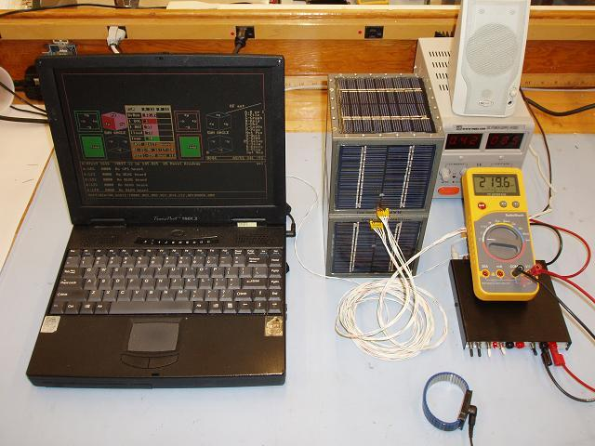
ATTITUDE CONTROL LABS: All of the four attitude control methods in space can be demonstrated with actual forces in the lab, by hanging the LABsat models on several feet of fishing line. The models can demonstrate passive magnetic alignment, magnetic torquing against the Earth’s magnetic field, momentum wheel torquing, and thrusters. Of course, the Gravity Gradient method is tongue-in-cheek because the fishing line is just a very strong gravity gradient! The momentum wheel and magnetorquing coils LABsats are shown below along with the small chemical thruster. The thruster experiment replaces the electronics stack with a light weight block of foam and uses a "match-head" thruster as shown below.
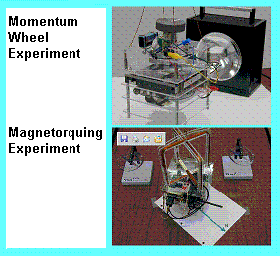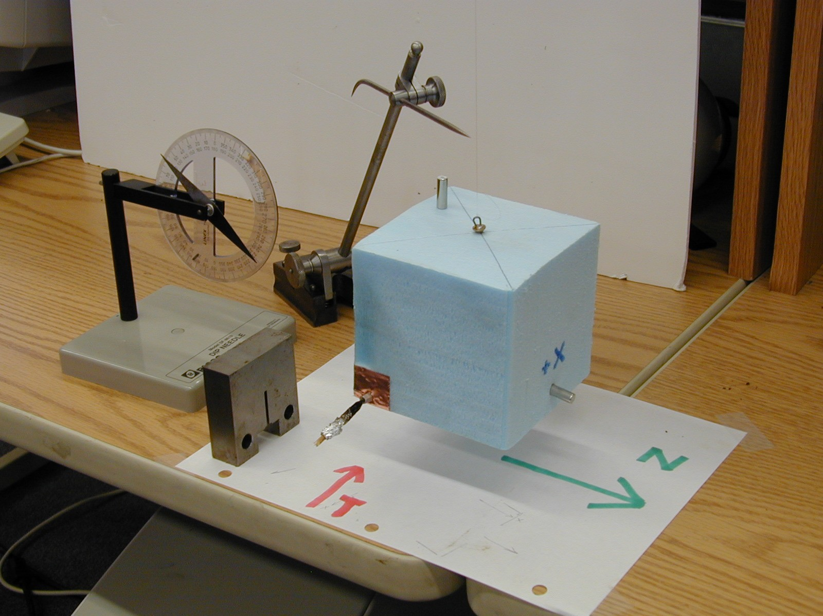
The image shows the FOAMsat aligned with North (using the small permanent magnet inserted on the +X face). The Thruster is inserted on the lower left -Y face and ignited. The moment of inertia is calculated and the resulting angular velocity is used to calculate the force of the thruster. The dip needle shows the orientation of the Earths Magnetic field in the lab for the magnetic demonstration.
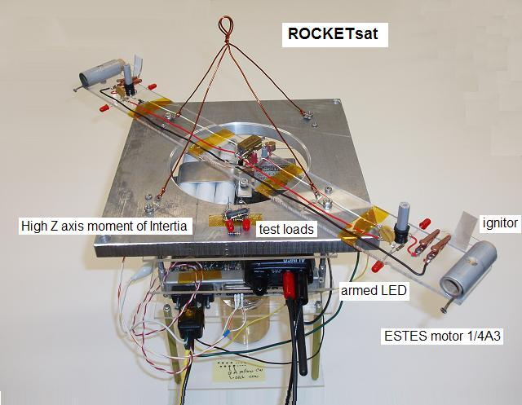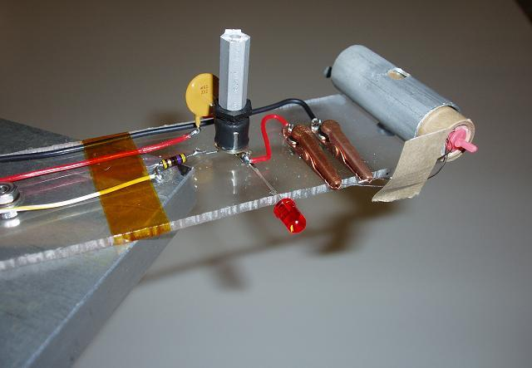
A more sophisticate chemical thruster uses a much more vigorous ESTES rocket motor on an actual LABsat as shown above. This satellite is hung outdoors but close to the lab window so it is easy to see. First the CW motor is fired to give the satellite a good spin. Then the CCW motor is fired and if they are close in performance, then the second motor will counteract the spin and return the satellite to rest in about 1 second.
SERIAL DATA COMMUNICATIONS EXPERIMENT: In this lab, the students analyze the serial data output of a GPS unit and connect it to the LABsat command-and-control system to transmit GPS position data to the ground station as shown below.
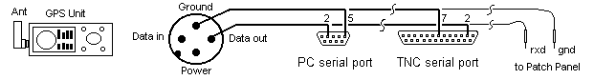
The data is then decoded and displayed on a local area map. Each GPS (since the experiment is conducted indoors) is pre-loaded with a simulated position. The students can not only manually parse the data fields for familiarity with the GPS NMEA data, but they can also transmit it on the air into the global APRS network as described below.
GLOBAL GPS Amateur Radio Tracking Network: The telemetry and GPS data transmitted by the LABsats is compatible with the global Amateur Radio Automatic Position Reporting System or APRS. Thus, any position data transmitted by the LABsats in the local area is picked up by this APRS network and fed into the global APRS internet system. Thus students can not only see where there LABsat’s are located, but cooperatively can see all other LABsatellites at any other school in the world.
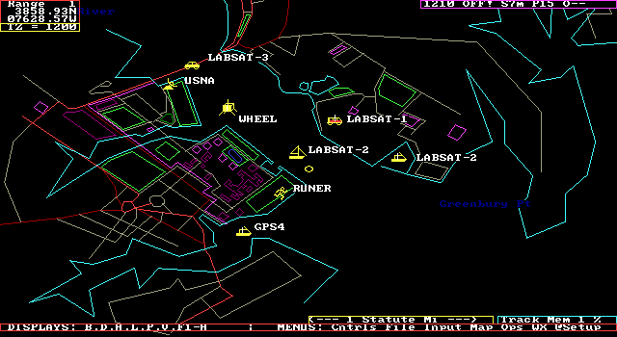
OTHER Experiments: Another advantage of the LABsat based experience for the students is that they can use it as the baseline for building and testing other sub components of their satellite design work. In the photo below, a LABsat model was used to test a string-cutter antenna deployment design for another student satellite design. In this case, the students could concentrate on the mechanical and structural details and simply use the LABsat as the control system.
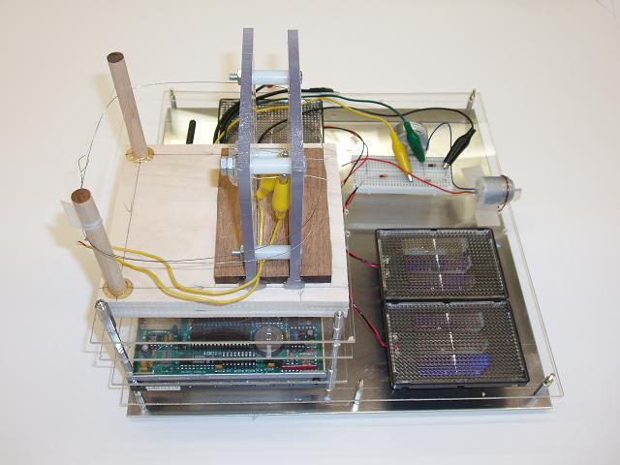
SATELLITE TRACKING: It is important to introduce students to satellite tracking. This is easy to do with a variety of low cost amateur satellite tracking programs. There are dozens of other university and interesting Amateur Radio satellites. When passes occur during lab periods, students participate in ground station operations. With a suitable antenna, the LABsats can be used as a Ground Station to transmit to, or receive from several of these satellites. The image below is used to help the students visualize the daily pass geometry of the International Space Station over our station. The ISS has Amateur Radio on board and is usually a good signal to receive anywhere on earth about 6 times a day with a simple whip antenna.
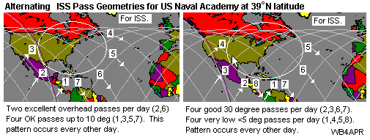
FLIGHT HERITAGE: The LABsat hardware is derived from the actual flight hardware used on several of the successful Naval Academy Satellite designs that have flown or are currently manafest. These systems are similar and compatible to what has flown on the MIR, ISS and the Space Shuttle for use by schools and universities around the world. By using a common Telemetry Command and Control system, the independent flight systems can actually be used in constellation with each other for multiple satellite experiments. Also, their commonality encourage colaboration with other schools making similar compatible systems.
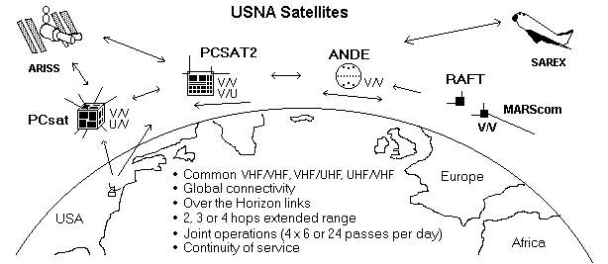
USNA SATELLITES: A total of eight independent Telemetry Command and Control Systems similar to othese LABsats have flown or have been delivered for flight as shown below. Both PCSAT-1, PCSAT2 and ANDE are dual systems, meaning they carry two complete systems each. The dual systems give redundancy, and also give multiple functionality. The RAFT and MARScom systems have single TC&C systems.
PCSAT 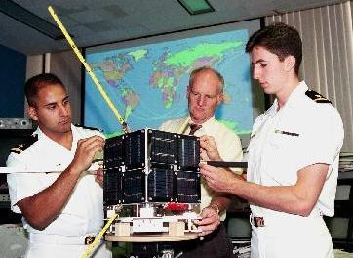 PCSAT2 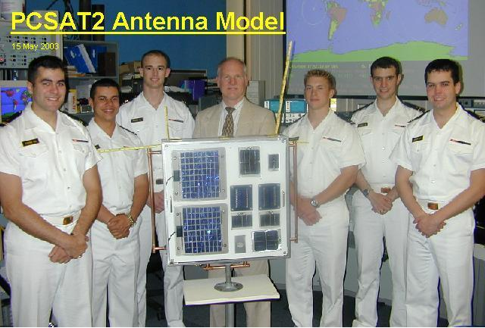
ANDE .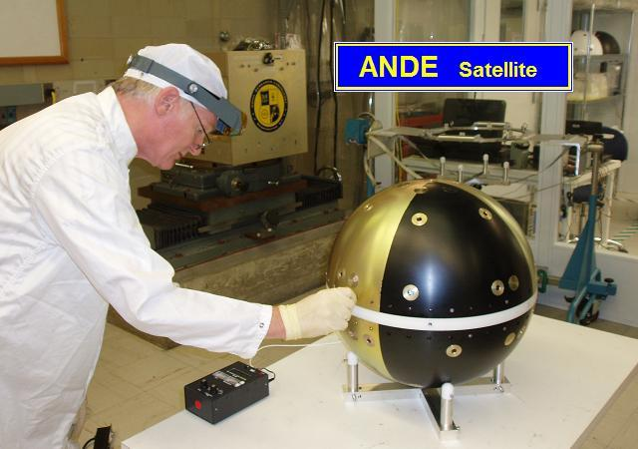 RAFT 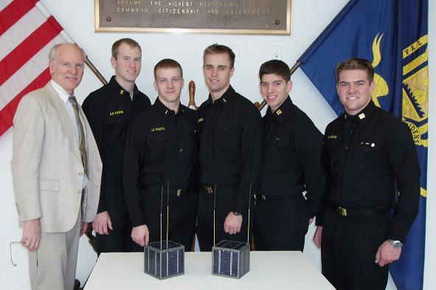
MARS . 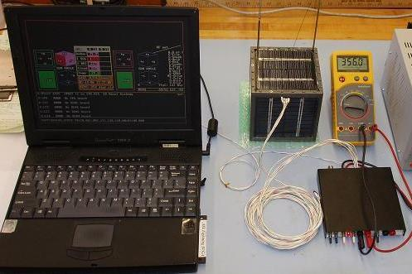 Parkinsonsat 